CHRIS CAMERON for SOUTH STORMONT COUNCILLOR
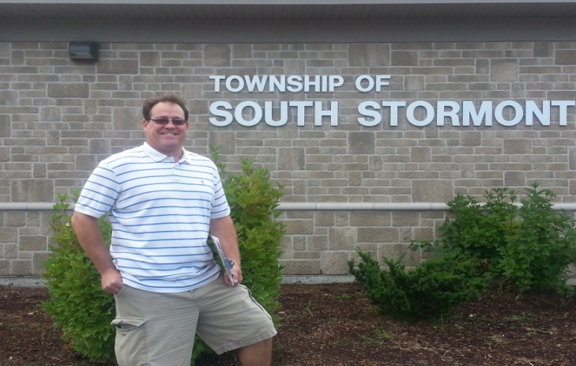

INTEGRITY COMPASSION HONESTY

SUNDAY SEPTEMBER 21, 2014 2-5pm
LIONS CLUB
17413 McPhail Rd. St. Andrews West

FEATURING ELIVIS TRIBUTE by MARC RIVETTE, accompanied by Joe & Larry Reigner

TICKETS $10 person $15 couple & Kids 12 & under free
(tickets available at door or call/text Debbie Cameron 613-363-3885 to reserve)

Light lunch will be served.

